Sales Analysis Report - Week 2
Prepared by: Samavia Muskan
Project: Sales Data Exploration

1. Introduction
The goal of this analysis was to look at the company's sales data and find out which products are performing well and which months are the busiest for the business. I used Python to create visual charts to make the data easy to understand.

2. Data Visualization
The following chart shows the total sales for each product category and the sales trend over the months:
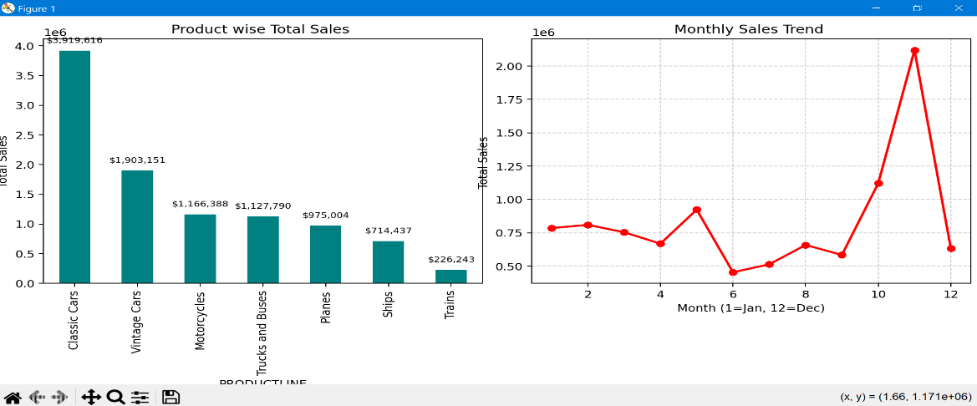

3. Key Insights
After analyzing the graphs, here are the main findings:
- Best Selling Product: 'Classic Cars' is our top-performing category. it generates the highest revenue for the company.
- Peak Sales Month: There is a huge spike in sales during November (Month 11). This is the most important month for the business.
- Low Demand: Products like 'Trains' and 'Ships' have very low sales compared to other categories.

4. Recommendations
- Prepare for November: Since November is the busiest month, the company should make sure all inventory is ready by October.
- Focus on Top Products: We should spend more on marketing for 'Classic Cars' as they are already very popular.
- Improve Low Sales: We can offer special discounts or "Buy 1 Get 1" deals on 'Trains' and 'Ships' to increase their sales.
Conclusion: The business is doing great, especially in the car categories. By focusing on the end-of-year rush, we can increase our profits even more.

